Building a Semantic HTML5 Personal Portfolio

Shruti Shrestha
International American University
CSE 230: Web Design and Development
Professor Chitrakar
28 September 2026

Contents
Introduction 3
Implementation 4
Source Code 6
Why is Semantic HTML important? 10
Version Control 11
Portfolio Repository link: 14
W3C HTML Validation 14
Conclusion 15
References 16

Introduction
In this article, a one-page personal portfolio is presented for the coursework of CSE 230 Web Design and Development. A simple portfolio site needs to be built according to a few structural requirements as part of the task. The entire site was designed using HTML5, with a focus on using appropriate and proper semantic attributes. No CSS, inline styling or other stylistic methods have been used. This criterion demonstrates that an accessible and functional website can be built using HTML only and also the importance of separating the structure from the visual appearance of a webpage.
The portfolio, which is divided into multiple significant areas, portrays a BIT student. It is divided into a header with a navigation menu, an About part containing a personal description and profile image, and a skills part containing a list of descriptions, and has project sections displayed as separate article elements. What's more, it features a contact form that allows visitors to easily fill out. The main purpose of this portfolio is to demonstrate the use of semantic HTML5 elements and how the webpage structure can be applied in practical situations. This paper discusses the functionality and design of the portfolio, the importance of semantic HTML, the end product of the webpage, and the HTML document's validation using W3C HTML Validator.

Implementation
Semantic structure
- Header and Navigation (<header> and <nav>): The header and navigation part holds the title (<h1>) and an unordered list (<ul>) of anchor links to different sections of the page
- Main (<main>): The main part contains all of the primary contents of the page with each major section divided as about and skills, projects and contact form.
- About and Skills: The about section contains a short biography, a profile picture of the user,
- Projects: The project section contains projects modules fulfilling the requirement of the assignment.
- Contact Form: The contact form includes <label> elements for input fields. The form includes fields for name, email, subject, message and a submit button.
- Footer: It holds the copyright line and location.
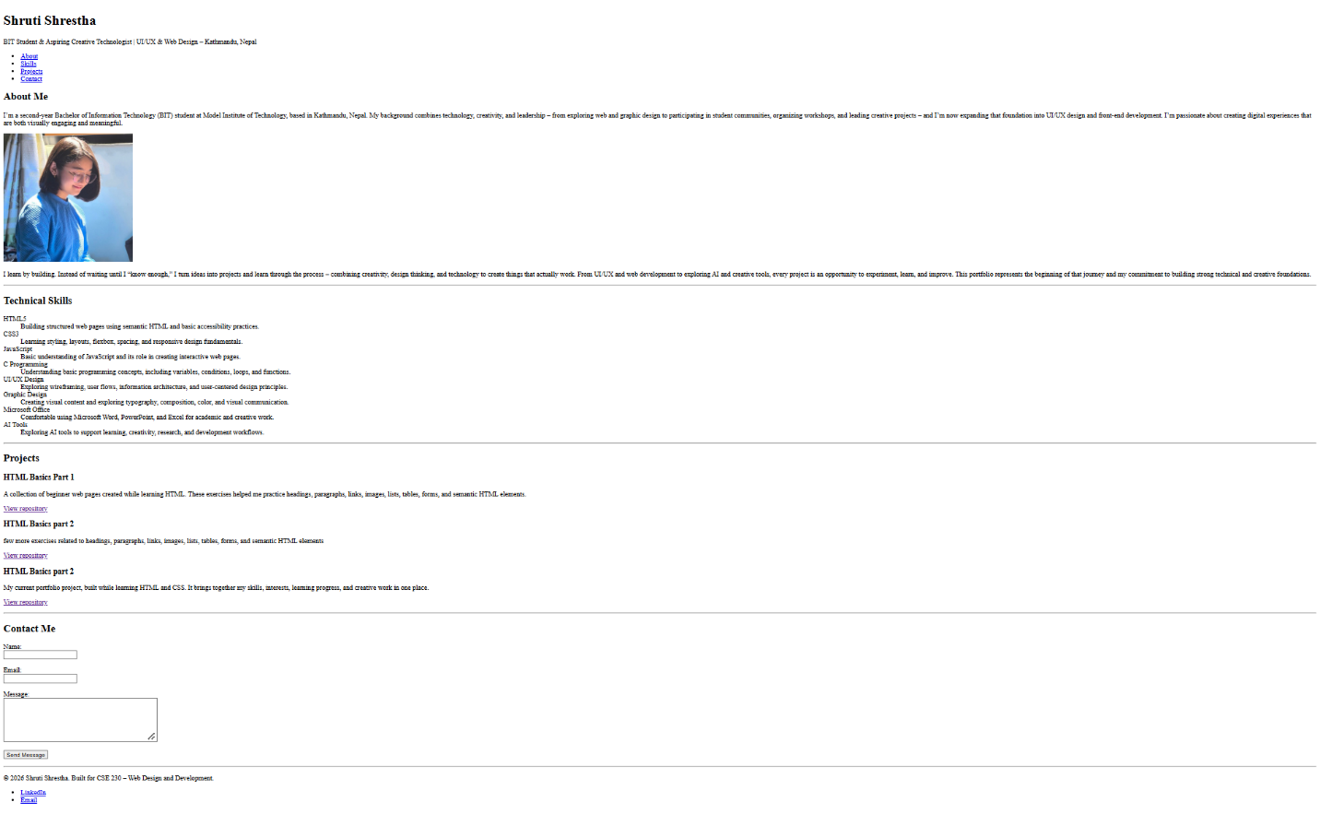

Source Code
The HTML code is used to build a single page personal portfolio for a BIT student interested in technology, UI/UX design, and web development. The first section of the page is a <header> element which includes the main title, a short introduction and a navigation menu. The navigation bar is an unordered list that includes links to head to the About, Skills, Projects and Contact sections. The main content of the portfolio is contained within the <main> element, which is broken up into various semantic <section> elements.
The About Me section includes a brief biography and a Profile image with alternative text. The Technical Skills section is provided in a <dl> description list, with the skills provided in <dt> elements and the description of each skill in <dd> elements. The Projects section has three different <article> elements, one each describing a project and giving a repository link. The Contact Me section has a contact form with clearly labeled <label> and <input> elements, an email field, a message <textarea> and a submit button. Lastly, it gives copyright details and contains LinkedIn and email links. Overall, the code provides a well-structured, clear and accessible portfolio, which is built using semantic HTML5 elements and no CSS or inline styling.
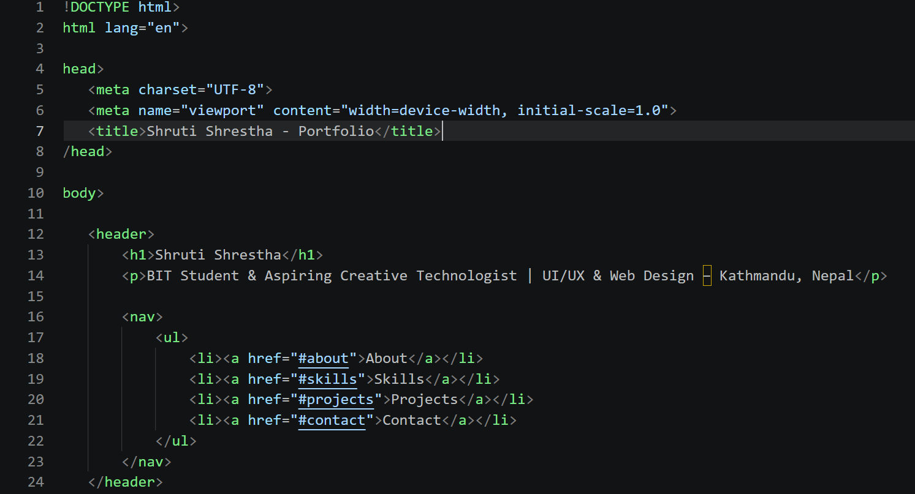
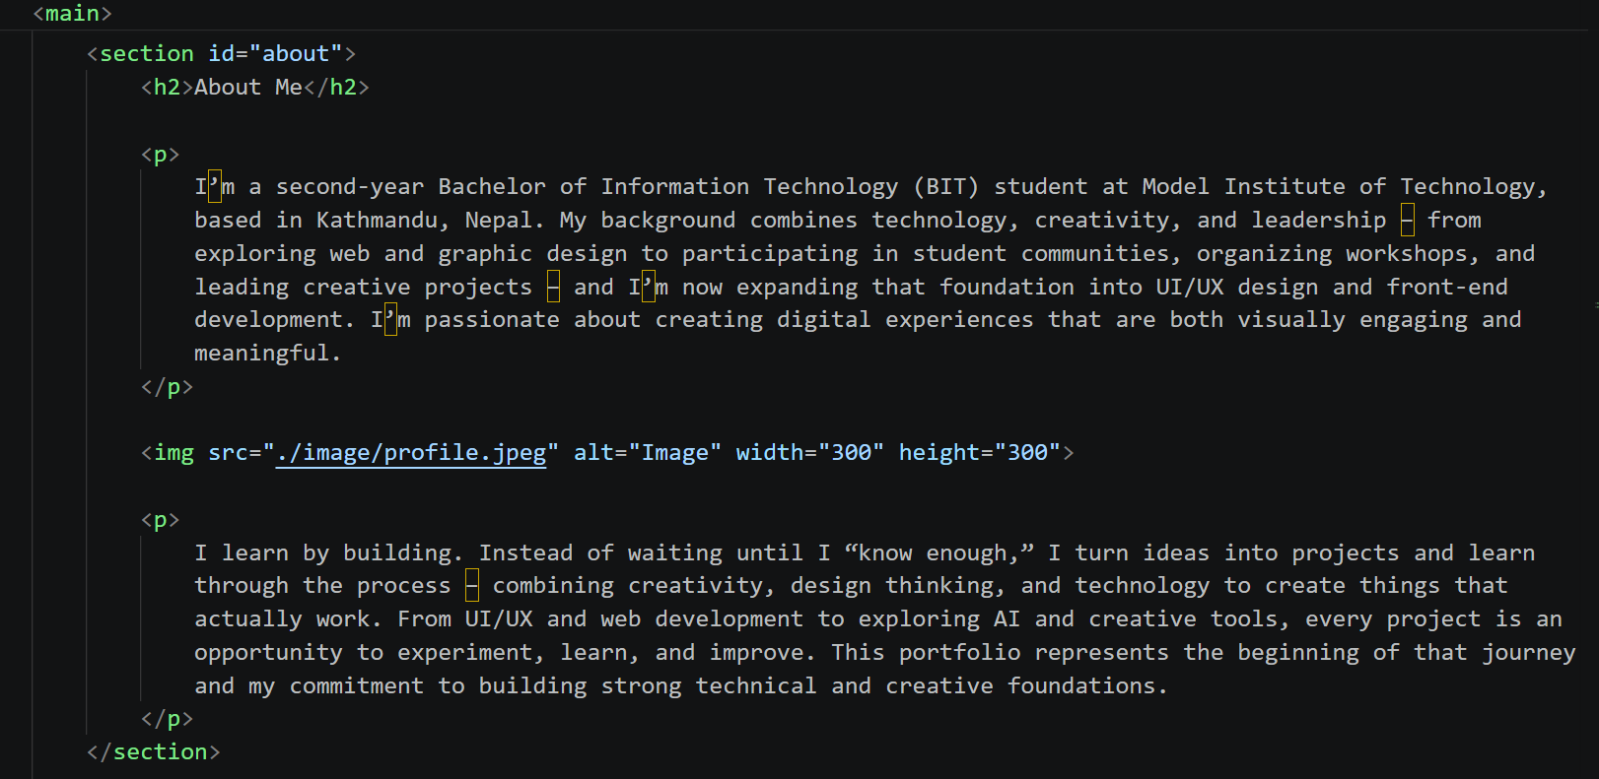
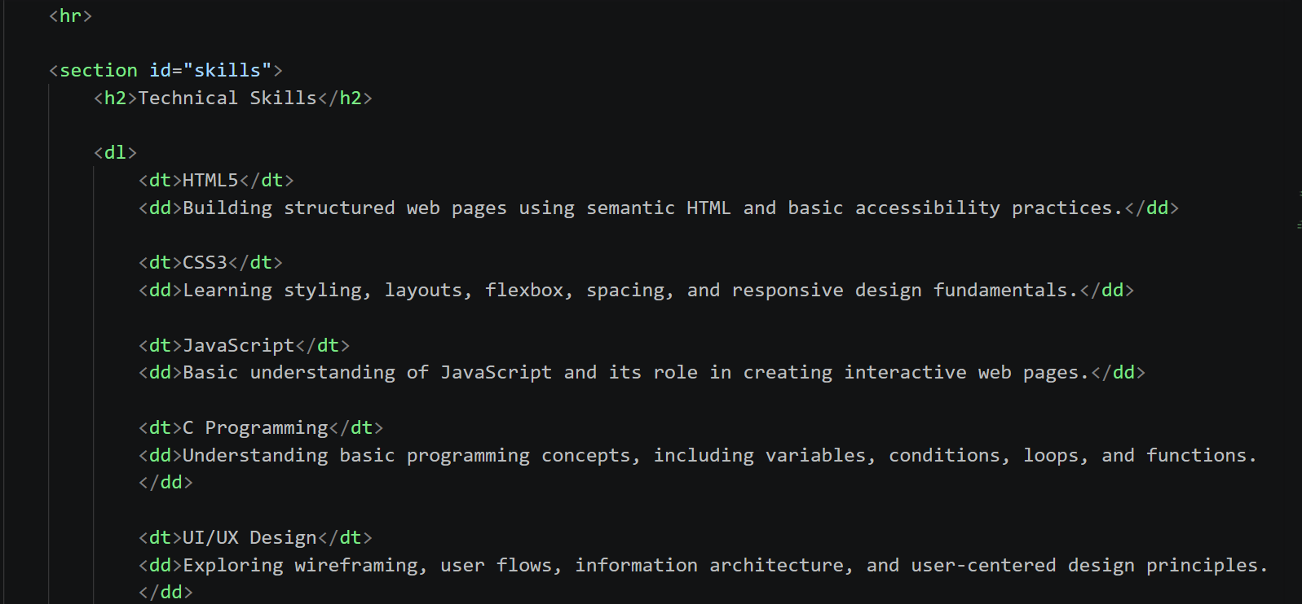
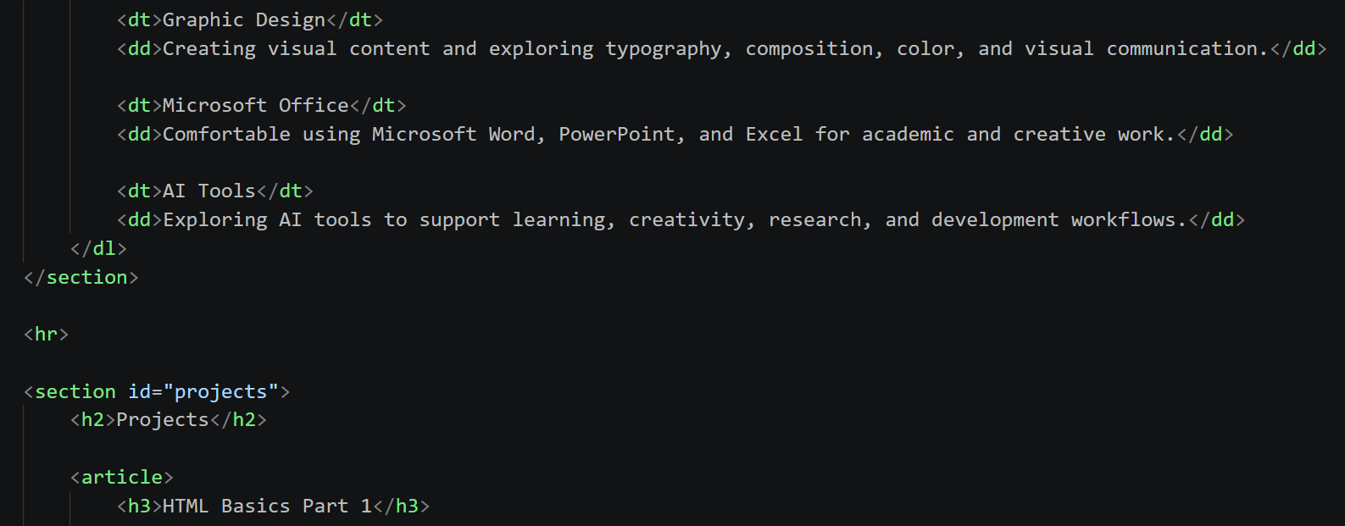
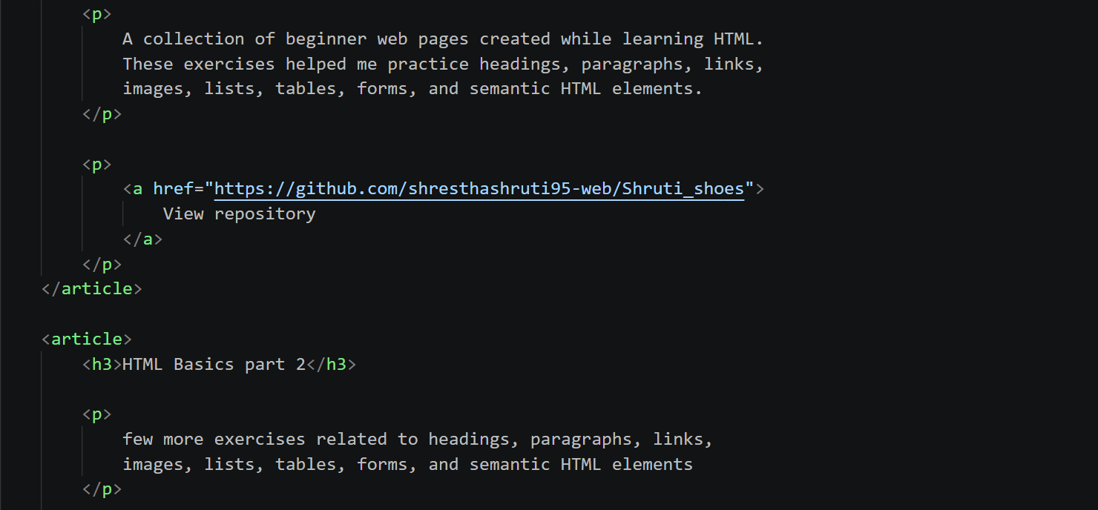
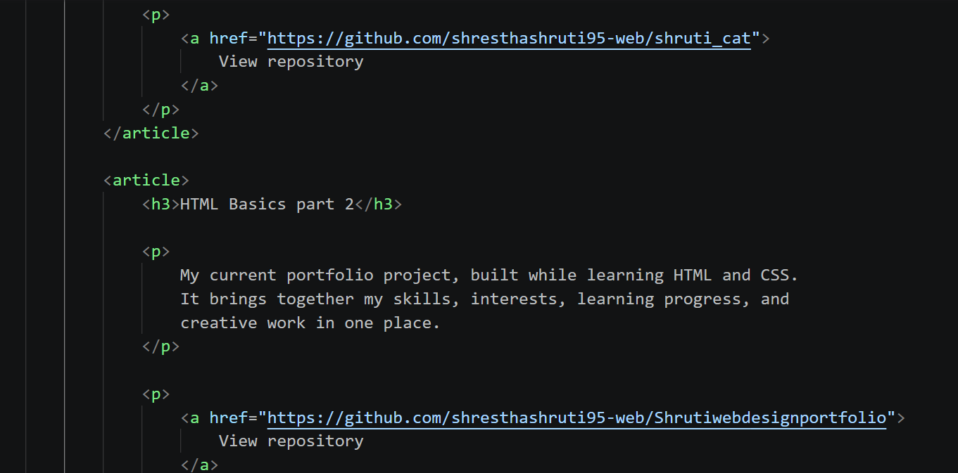
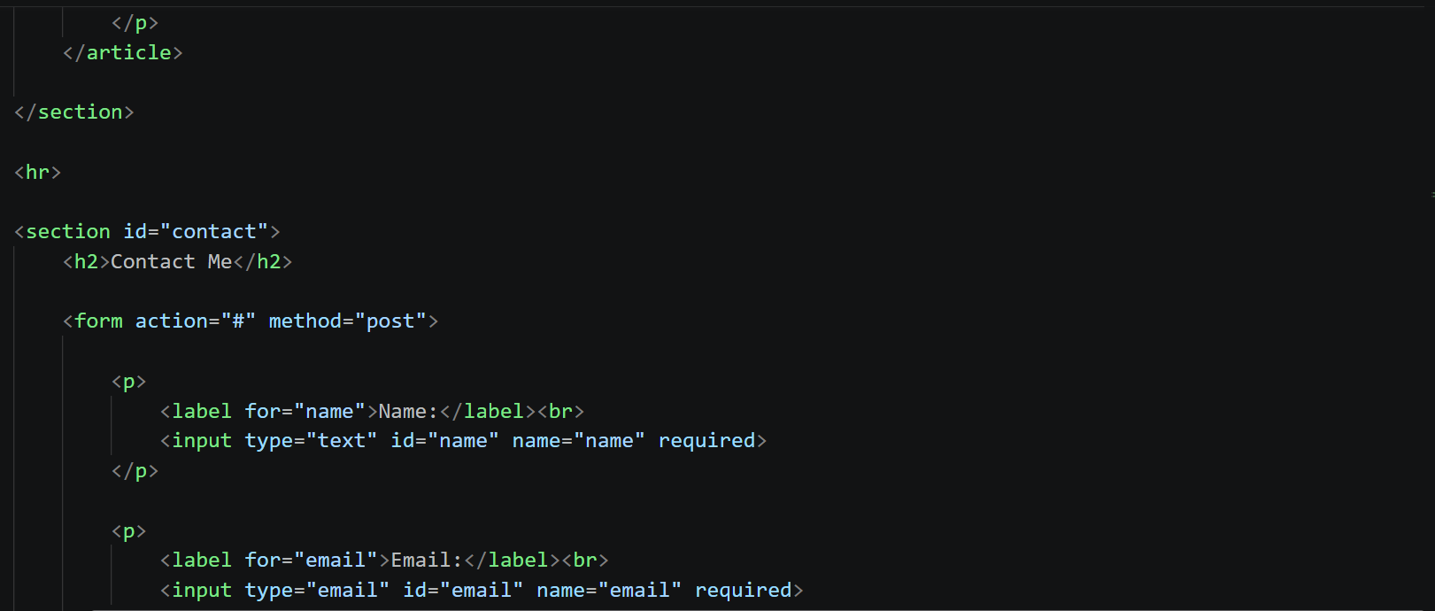
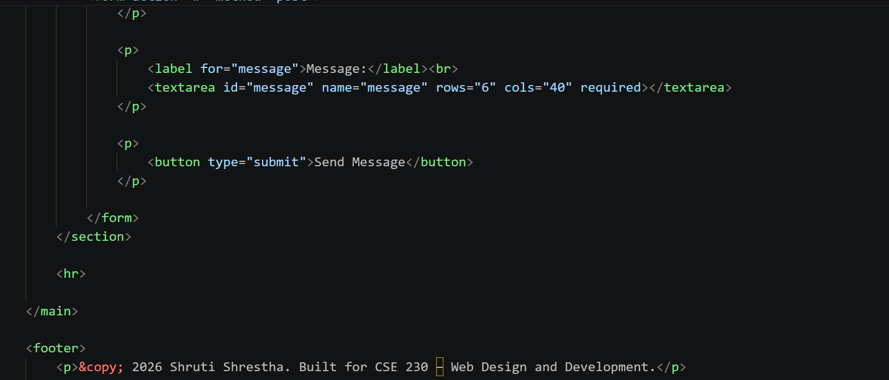
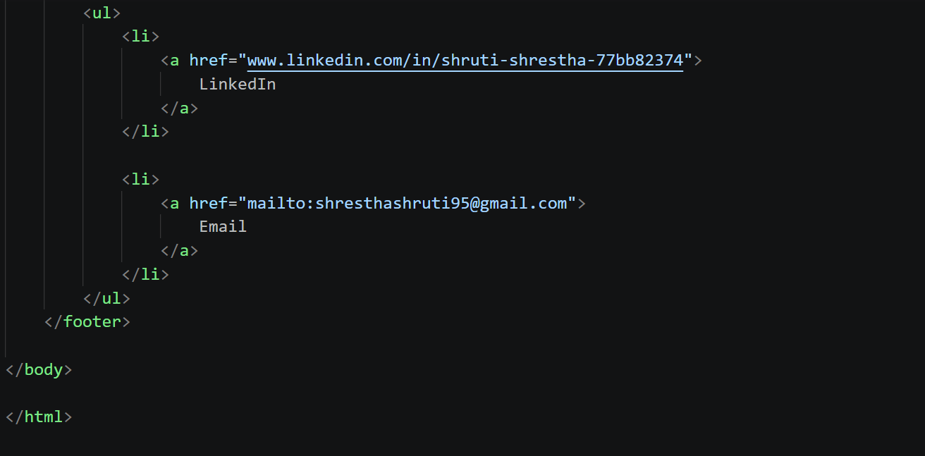

Why is Semantic HTML important?
The need for Semantic HTML is significant because it provides the content of the website page with meaning. The use of some elements like <header>, <nav>, <main>, <section>, <article> and <footer> give a clear indication of the role of each component of the page. This makes the HTML code easier to read, understand and maintain. Semantic elements describe the meaning of the content, rather than its presentation.
Semantic HTML also makes the web page easier to interpret and understand by screen readers and other assistive technologies. It can also facilitate search engines to comprehend the structure and content of a website. Semantic HTML is particularly significant in this portfolio, as there is no room for styling (CSS) and other approaches. Thus, the HTML elements should present a unified, logical and accessible layout for the whole page.

Version Control
The final portfolio.html file and the image folder were committed, pushed and was made publicly available for review outside the local environment from a GitHub repository.
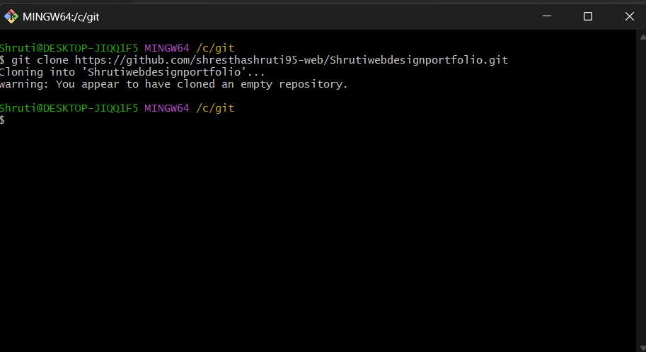
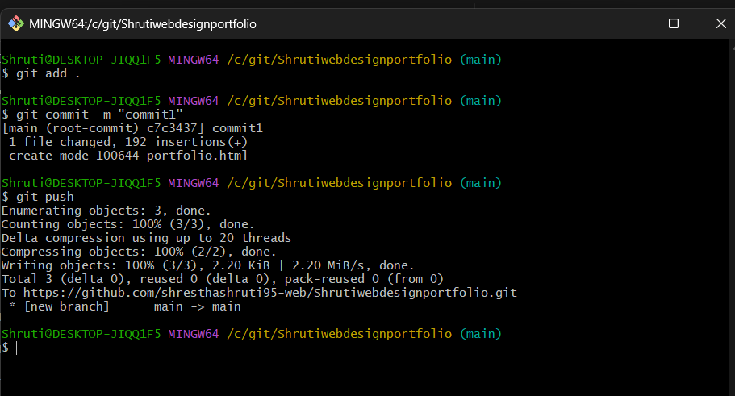
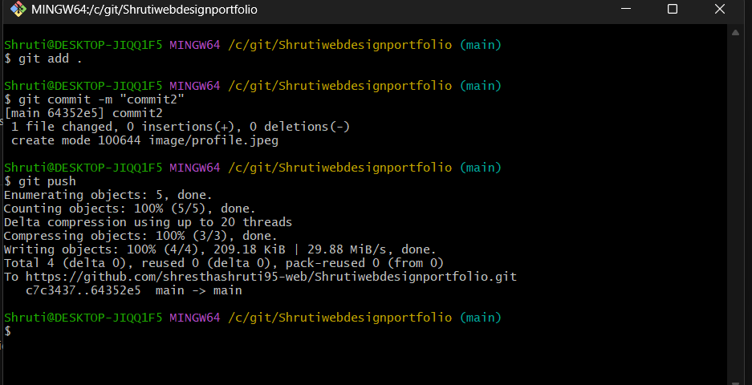

Portfolio Repository
Link to repository: https://github.com/shresthashruti95-web/Shrutiwebdesignportfolio
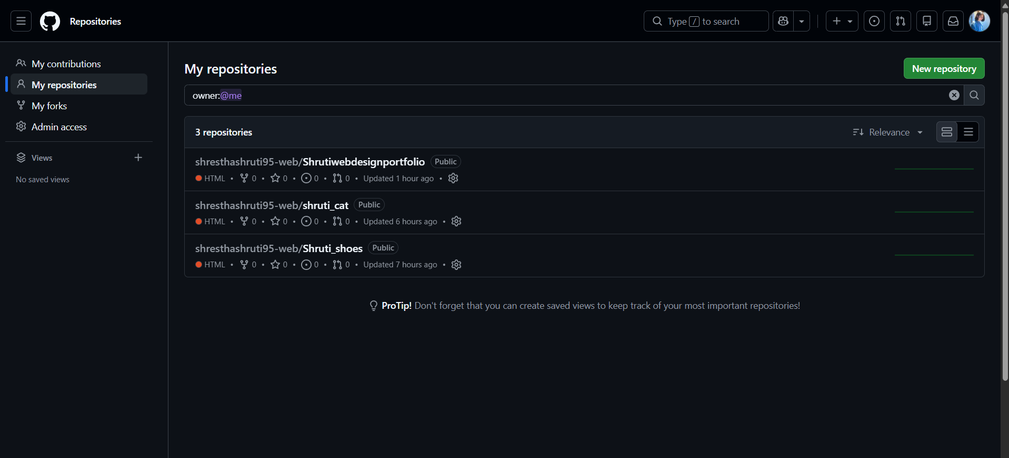
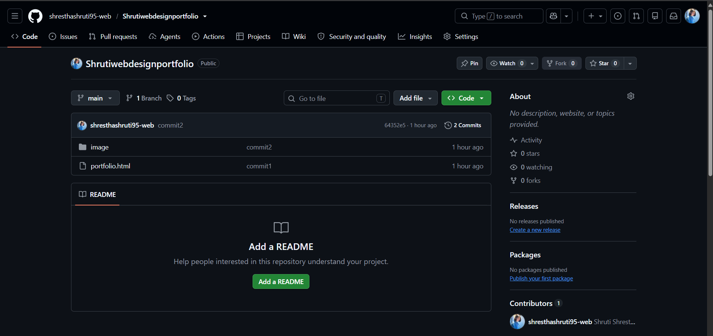
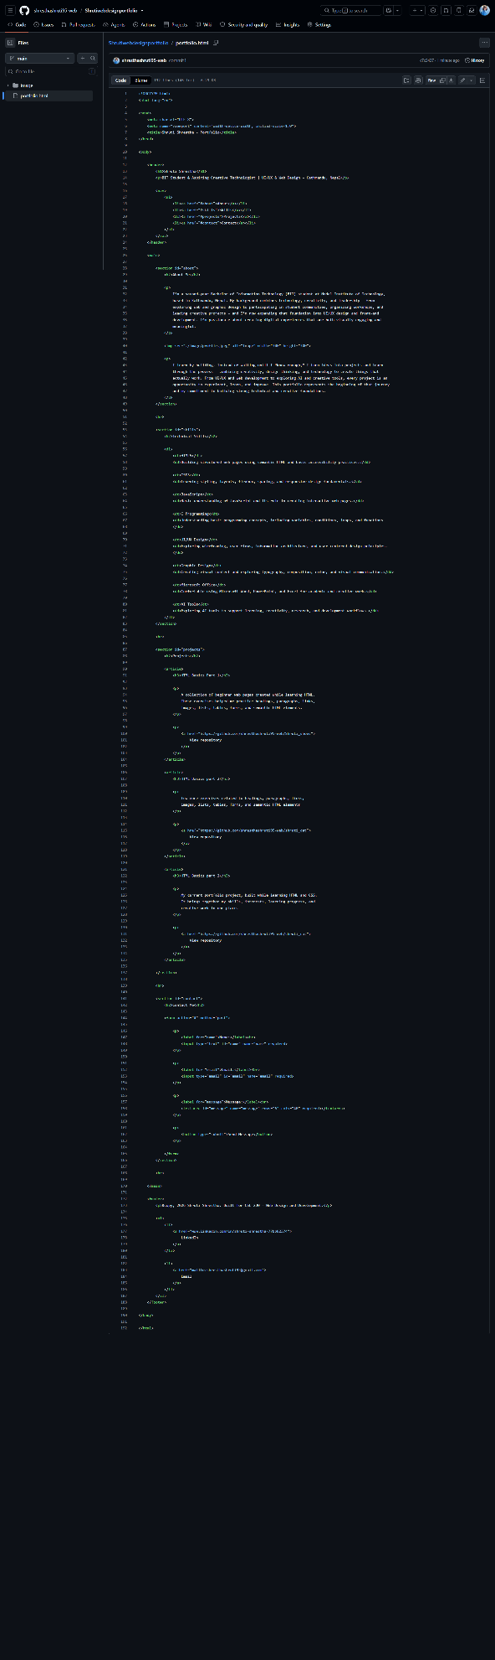

W3C HTML Validation
The uploaded html code was checked for mark-up validity using W3C Markup Validation Service through file upload method. The result of the validation shows “Document checking completed. No errors or warnings to show” which proves that there were no structural mistakes, missing attributes, invalid nesting or unclosed tags in the code.
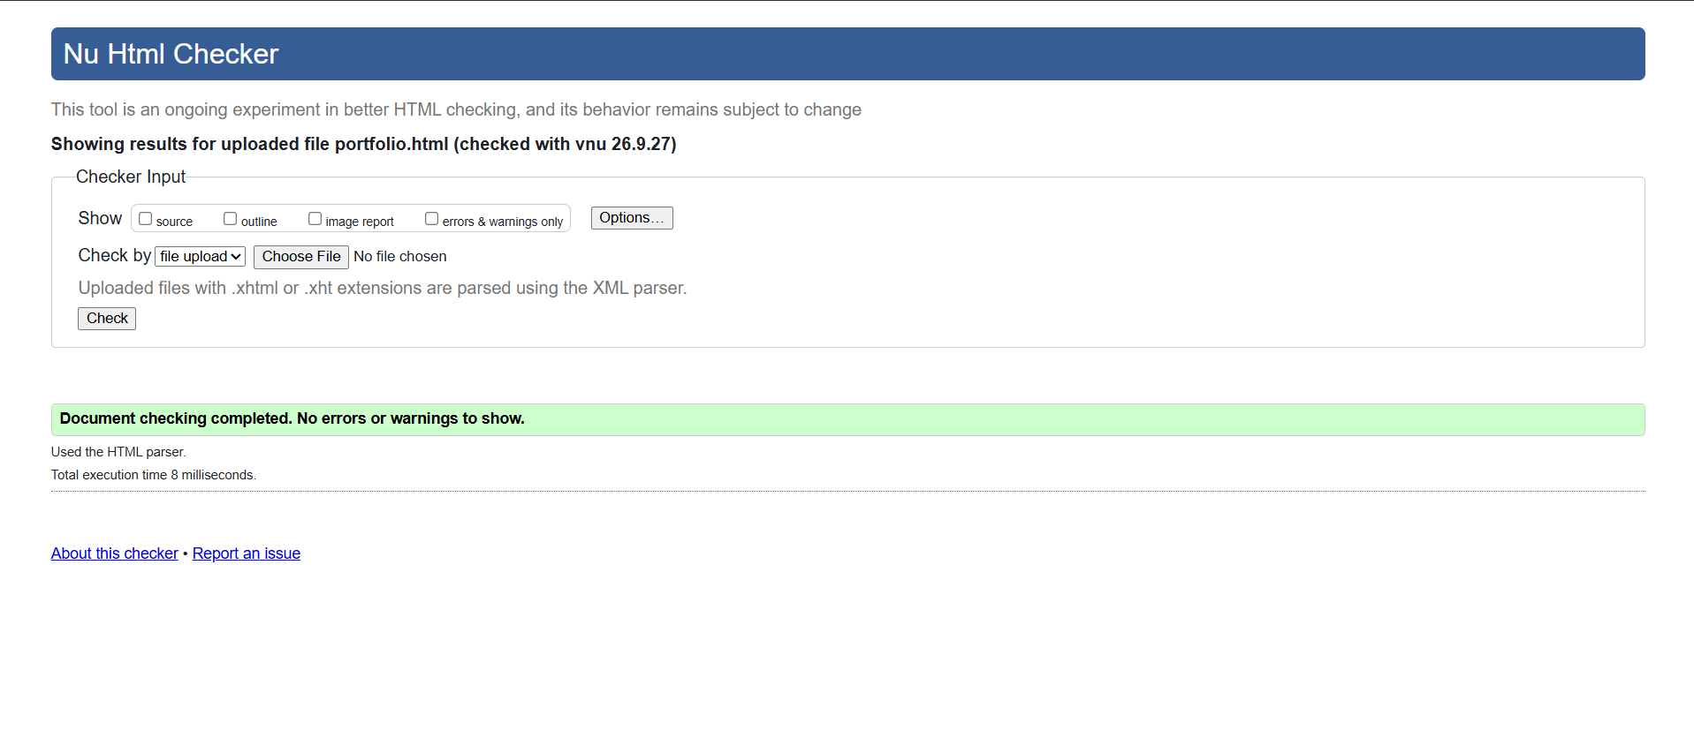

Conclusion
I believe that I have gained the following lessons from writing HTML that didn't make use of any CSS. The following have been my "lessons" from writing HTML without using any CSS. As CSS wasn’t used it seemed that the only way to get the projects section to look structured and to have the skills portion look like a description list, was to use the article tag for the projects and the description list for the skills. Similarly, some semantics are shared across all forms, including the pairing of each form field with its text label, which also aids accessibility of the site. This knowledge is very important for the next steps as it gives the theoretical skills about semantically creating HTML which can be styled using the CSS (Minnick, 2021).

References
Minnick, J. (2021). Responsive web design with HTML5 & CSS (9th ed.). Cengage Learning.
Brown, E. (2019). Web development with Node & Express: Leveraging the JavaScript stack (2nd ed.). O’Reilly Media.

